Rehired Retiree Appointment Management

Process Action | Responsible Party
Prepare rehired retiree appointment hire and appointment extension justifications | Supervisor with support from HR Field
Hire and Onboarding process | HR Shared Services
Track and monitor 900 hours | HR Field
Track and monitor appointment expiration dates | HR Field
End appointment earlier than scheduled | HR Field
*End appointment as scheduled | Ticket initiated by HR Field, but termination processed by HR Shared Services

*Process to End Appointment as Scheduled

Once it has been confirmed with the division/supervisor that the Rehired Retiree appointment will end as scheduled and no extension request will be submitted, the HR Field contact (or supervisor) will initiate the termination action in askUS (askus.lbl.gov) as follows:

Step 1: In the Human Resources service area, select “Employee Appointments and Resignations”

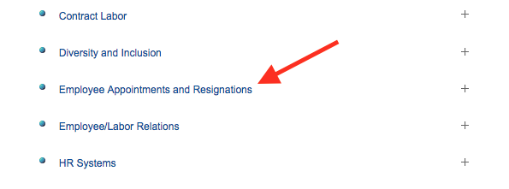

Step 2: Select “End and Employee’s Appointment”

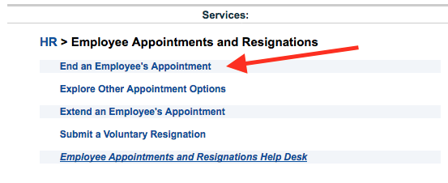

Step 3: Complete the form by filling in the applicable fields

- Are you requesting this for someone else?: Yes
- Requested For: Supervisor name
- Employee Name: Retiree name
- New Termination End Date: Enter end date (can be same value as the “Current Appointment End Date” field
- Comments: Enter “Rehired Retiree appointment expiring. No extension will be requested”

